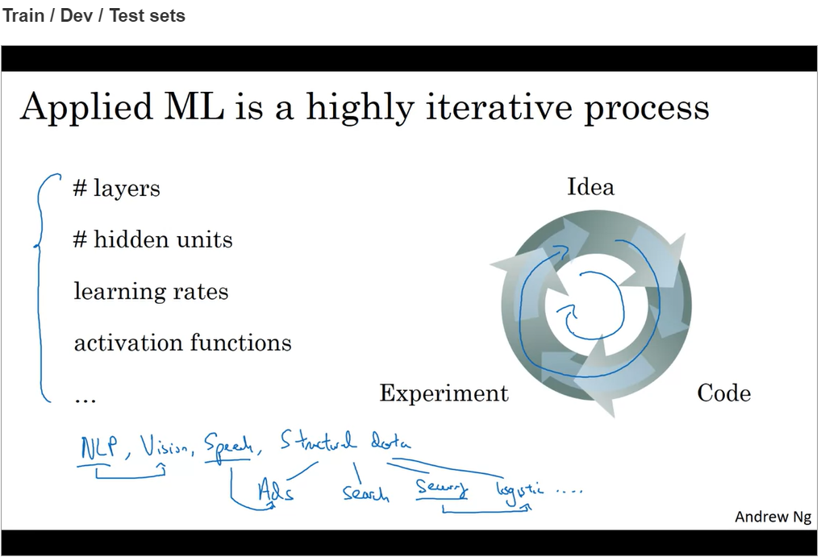

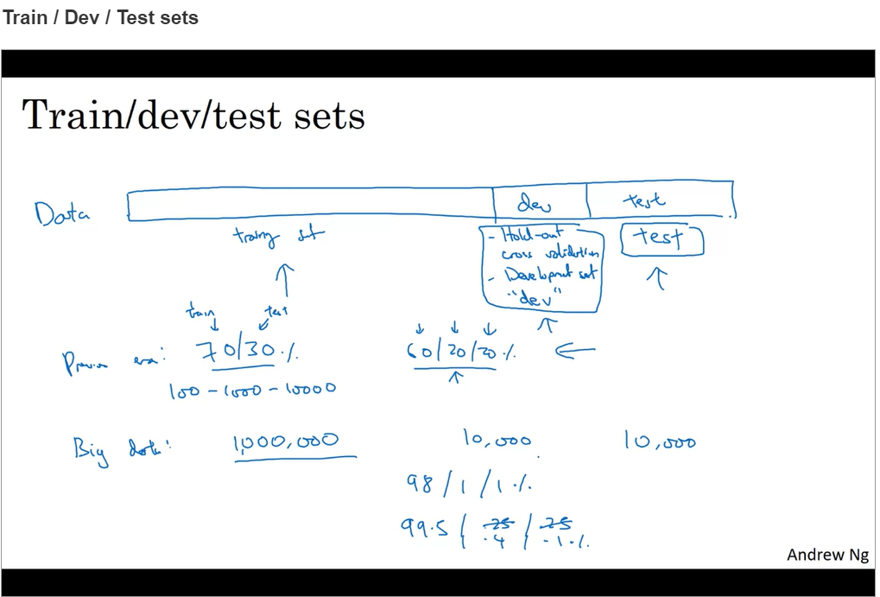

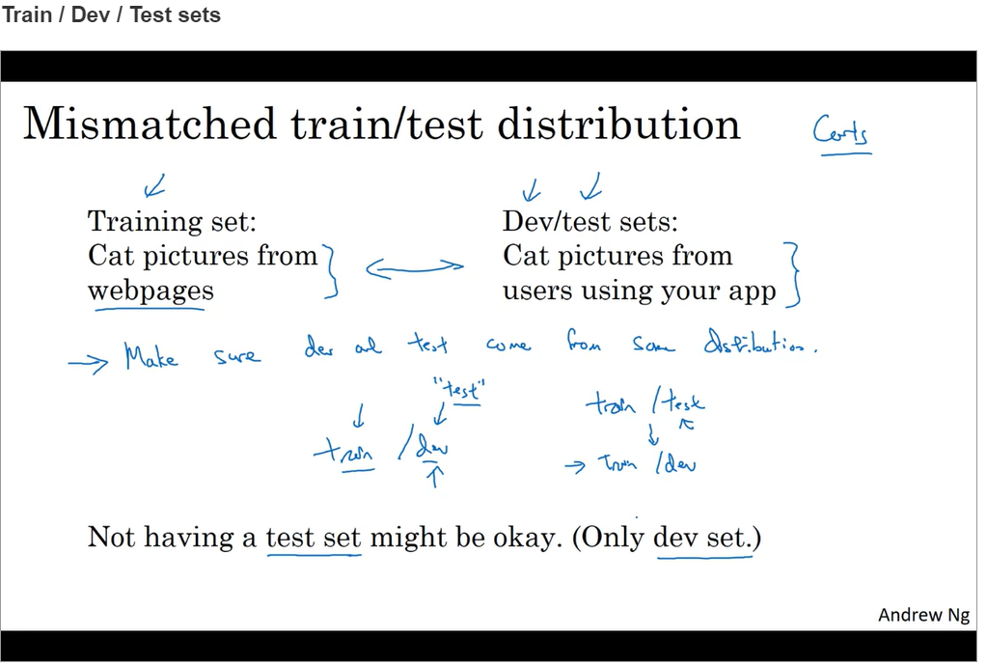

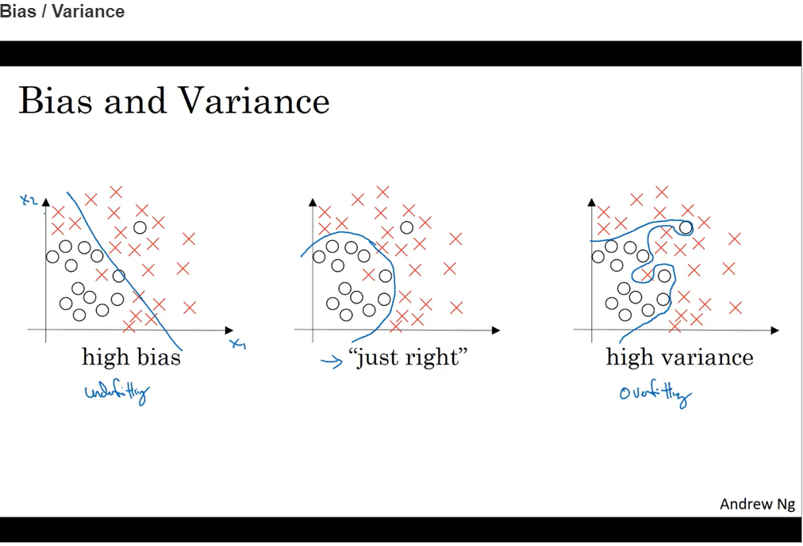

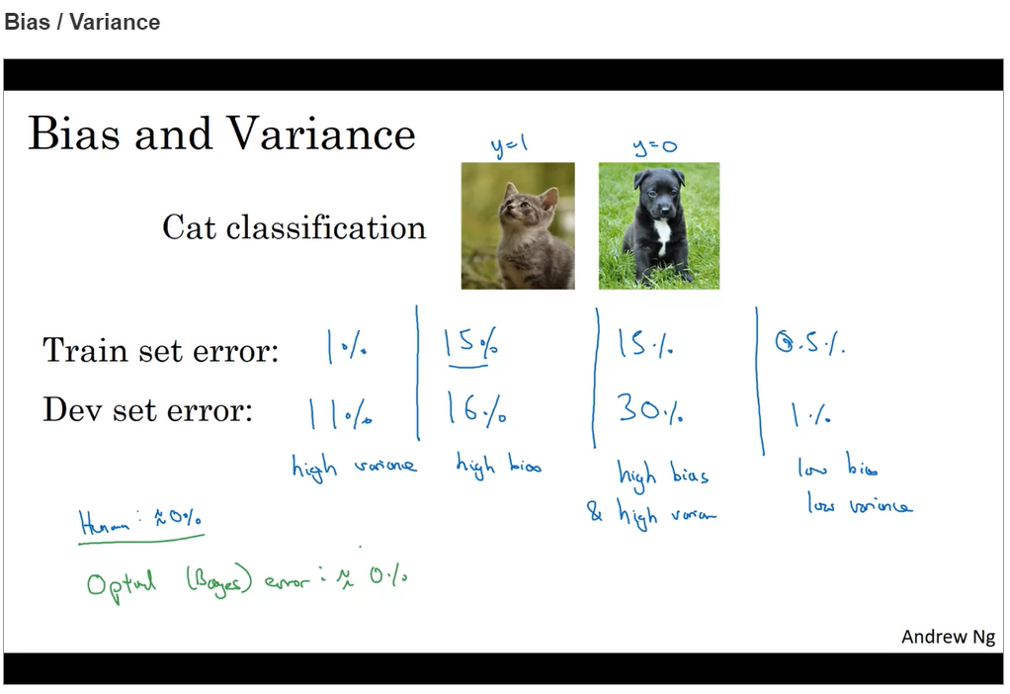

* **High variance (occurs when dev set error is significantly larger than train set error) = Overfit**
* **High bias (occurs when train set error is significantly larger than optimal error [also called as Bayes error]) = underfit**
* **Low bias and low variance (when train and dev set errors are not significantly large) = just right**
* **High bias and high variance ( occurs when train set error is significantly larger than optimal error and dev set error is significantly larger than train set error)**

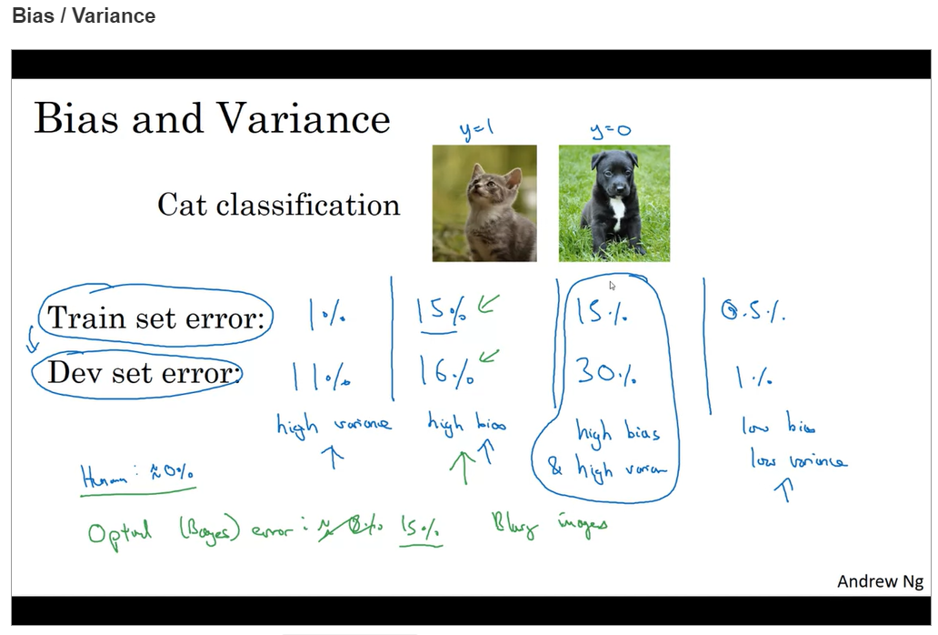

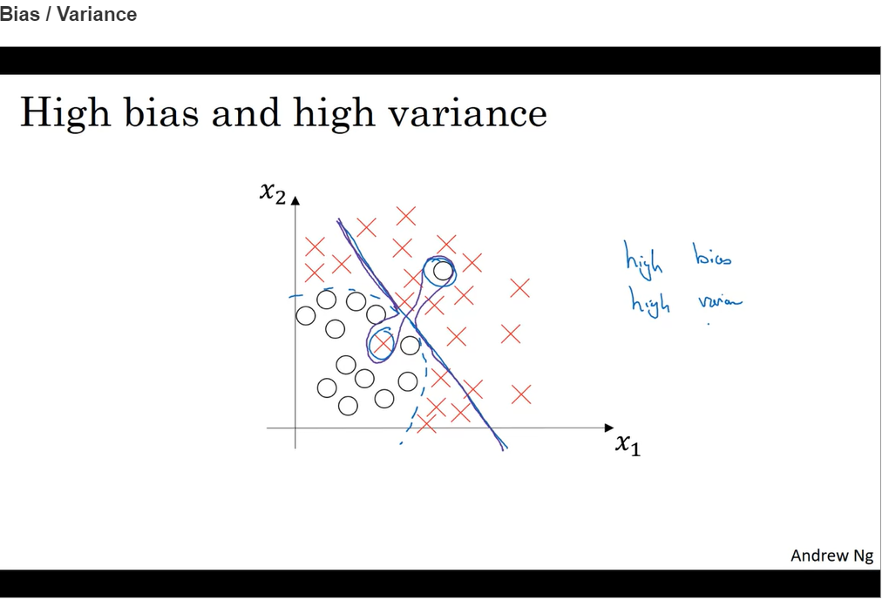

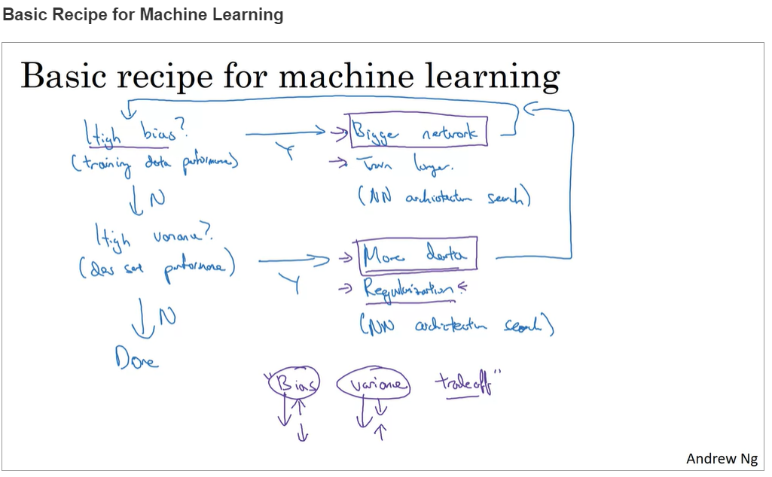

1. **High Bias? 🡪 Use bigger networks like more hidden layers or more hidden units/run longer/ try some advance optimization algorithms/(find better suited NN architecture)**
2. **High variance? 🡪 Get more data if possible/ regularization/( find better suited NN architecture)**

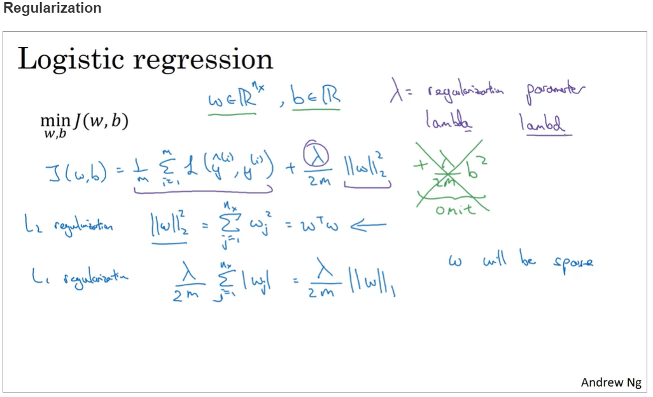

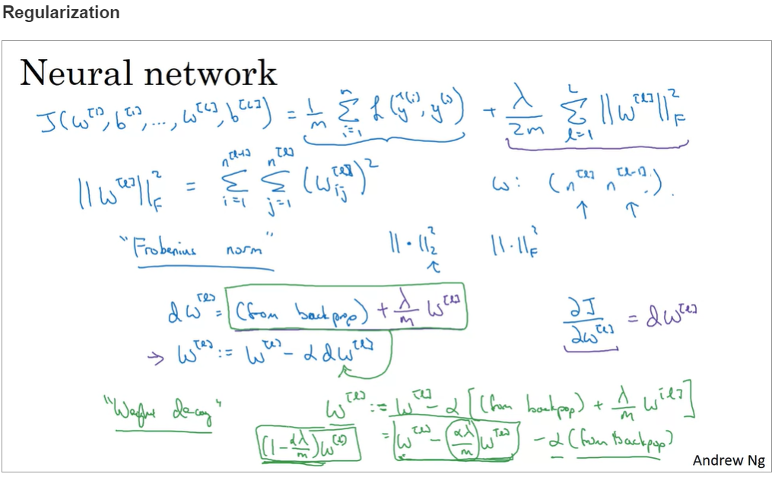

**Correct Formula below:**

